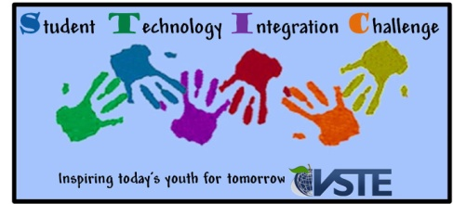
STIC Desktop Publishing Contest Information

Expectations and Guidelines:
- Students may submit an original, written product that has been computer-generated. The entry may be fictional or non-fictional about a topic of the student’s choice. The writing piece will be judged by the following criteria:
- Curriculum Alignment
- Ideas
- Content
- Purpose
- Visual Appeal
- Organization
- Conventions
- Sponsors may submit up to 2 entries for the Desktop Publishing Contest per grade level categories.
- Lead sponsoring teacher must be a member of VSTE.
- Grade level categories are Pre-Kindergarten-2, 3-5, 6-8, 9-12
- One winner will be selected per grade level category.
- Entries must be completed by individual students. No group entries will be accepted.
- Only students attending schools in the state of Virginia are eligible to participate in this contest.
- All entries must have been completed between April 2011 and October 1, 2012.
- All entries are submitted via the entry form.
- A completed entry form must accompany all entries.
- If any material is copyrighted, please attach authorization for its use.
- One free registration to the VSTE conference will be awarded to each winner’s lead teacher sponsor.
- Student winners and their teacher from each grade level category will receive a prize that will be awarded at the VSTE conference during an afternoon ceremony on Sunday, December 2, 2012.

Not a member of VSTE?
Sign up now to participate in the contest.
http://www.vste.org

